Assignment 3
Distributed systems
Sprencz Róbert
In this assignment, our task was to implement a chat microservice, then integrate it with the rest of our microservices. Another thing to consider was security.

Conceptual architecture
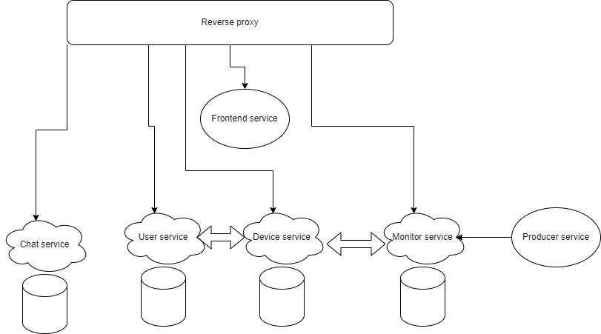
Since we already had a reverse proxy, I determined that the chat microservice will use it too.
The chat microservice can handle both HTTP and Websocket connections. Both of these travel through the Caddy reverse proxy.
User service
Added a get method to check if a user is an admin and another method to get the list of people a user can chat with.
Device and monitor services
Unchanged
Frontend service
Added a few new routes. These are focused on the new chat features.
Clients can start conversations with admins only.
Admins can start conversations with whoever they want and they can also make announcements that all the clients and none of the admins can see.
With the help of websockets conversation participants can see whether the other participant has read their message (by opening the conversation), or if they are typing in real time inside a conversation, or they can follow admin announcements and when they are added to a conversation in real time.
With the help of a Singleton pattern, we can keep the same connection over multiple pages.
Security
A central part of this assignment was for us to use JWT. As my application was made with a NodeJS backend, I decided to use the jose library. Since I have taken security into consideration from the first assignment, I had a very minimal TODO list. All microservice entrypoints are secured with JWT.
I also used JWT to consider what user is making the request and filter results accordingly. At this point every microservice has the same secret key stored in a .env file. The token is assigned at login time and validated inside a validation middleware. For the websockets, the token is also used to track which user has made the connection and is inserted into a Map.
Build and execution considerations
All microservices run now in docker and the reverse proxy is still set up with Caddy.
